Literacies

In the image below are examples of different types of literacies. But there are many more than this. Take a few minutes and think about what you see below, or anything else you became “literate” in.
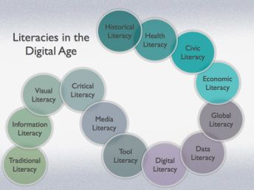
- What are your literacies?
- What was your motivation to develop these literacies?
- What was your process of developing them?

