Burke’s Pentad Activity

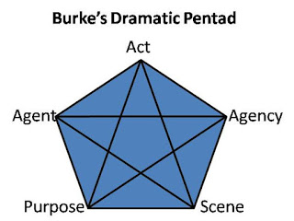

- For the text you are reading, define each category and say how they relate to the other categories in 2-3 sentences (for each)
- FYI, the agent is the author, the agency is their ability to act (expertise, credentials, the opportunity that has been given to them to write/speak), the act is what they are actually doing or saying, the scene is where the act occurs, and the purpose is why they are acting
- Write 2-3 sentences on how you understand the text you are reading and writing better as a result of applying this criteria
**A student can also apply the same criteria to the essay they are writing, as a cover letter

